*Completion Report*

*Ethan Dunzer*

*06/06/2021*

**Table Of Contents**

**1. Figures** (pg. 3)

**2. Executive Summary** (pg. 4)

**3. Introduction** (pg. 5)

**4. Project Scope** (pg. 6)

**5. Inquiry Methods** (pgs. 7 – 10)

**5.1 -** Use Cases

**5.2 -** Data Flows

**5.3 -** Entity Relationships

**5.4 -** Structure Design

**6. Inquiry Findings** (pg. 11)

**6.1 -** Requirements for Project Design

**7. Project Challenges** (pg. 12)

**8. Conclusion** (pg. 13)

**9. Appendix A** (pgs. 14 - 15)

**10. Appendix B** (pgs. 15 - 19)

**Figures**

Figure : APC Use Case Diagram (pg. 8)

Figure : APC Data Flow Diagram (pg. 9)

Figure 3: APC Structure Chart (pg. 10)

**Executive Summary**

**Introduction -** An overview of why this document was created and what is in the completion report.

**Project Scope -** Describes the main functions that will take place in the project along with giving more background to the project.

**Inquiry Methods -** Explains the approaches and strategies used in this project to reach the findings.

**Inquiry Findings -** An overview of the inquiry results and what is needed in this project.

**Project Challenges -** Explains the problems that could arise and challenges that took place during this project.

**Introduction**

APC needs to expand and capitalize on their current standing in the publishing house market. The goal of APC to increase their business growth by 85% over the next 3 years. This will be achieved by creating better tracking then the current system has to offer, create better relationships with authors, creating a better outreach process to help their appearance to outside authors, and to adjust there “ideal market image” by what is trending.

APC’s new venture into their system update will increase their value as a business in several key areas. First it will solve their most notable problems that all involve lack of organization through not having a digital ecosystem. By creating a digital environment to take in manuscripts and store information about them as well as authors, trends, and published books there will be more information to look over and analyze for the future. This will not only help them after the initial upgrade, but it will also enable them to be in a better position in the future when they have more expansion or change.

Given APC’s current position in the market as a publishing house with very little overhead they can initiate these changes with the opportunity to bring in more revenue with almost no increase to their current overhead discounting the potential hiring that would give them 11 total employees.

*Constraints:*

* Changes will have to be made to the current office ecosystem.
* New contracts will have to be created for different types of print faces (hardcopy, digital, eBook)
* The overall system instillation will have to start soon in order to keep up with market growth and APC’s potential in that market.

In the following document information, there will be explanation of all the different tools and design elements that were used in creating this project. As shown in the table of contents there are 4 sections within inquiry methods which will detail the different tools that were used and why to achieve the goals of the functional and nonfunctional requirements. Then after that there is 1 section that explain the inquiry findings of this project along with physical requirements that APC would have to implement for this project.

**Project Scope**

APC's venture into a new business model will require them to upgrade all current workstations and printers, along with adding more for future employees. They will also have to explore cost and feasibility options for server storage for all their future digital documents. This technical information is not important for the immediate APC team but will need to be explained to Ms. Burdett to get approval.

The new system not only has to upgrade hardware components of their current system but also the functionality of it. In order to streamline their new business processes, they need to shift from a paper-based system to digital in order to keep accurate and better track of their projects. This will help with efficiency, but also information loss which they detailed as a huge problem in their current system. Since all projects will be digital, they can be further organized and categorized by genre and trend to make decisions for the collective easier. Below are the main requirements that APC has made important and will be taken care of in this new system.

* Submit manuscripts electronically.
* Track manuscripts progress through review process
* Categorize manuscript by genre, subject, and publication type (print or eBook).
* Contracts and their progress
* Pre publish book ISBN assignment.
* Sales from published books
* Author’s sales and publications
* Distribution of published books

Given APC’s current position in the market as a publishing house with very little overhead they can initiate these changes with the opportunity to bring in more revenue with almost no increase to their current overhead discounting the potential hiring that would give them 11 total employees.

**Inquiry Methods**

**5.1 Use Cases**

The new system not only has to upgrade hardware components of their current system but also the functionality of it. In order to streamline their new business processes, they need to shift from a paper-based system to digital in order to keep accurate and better track of their projects. This will help with efficiency, but also information loss which they detailed as a huge problem in their current system. Since all projects will be digital, they can be further organized and categorized by genre and trend to make decisions for the collective easier.

The following high-level business processes will be what the APC system will focus on and strive to accomplish. Overall, these 6 processes are combinations of smaller low-level processes that could be fixed/solved by creating a single process. For example, a single low-level problem that APC was having was lack of information when presenting manuscripts to their Collective Members. In order to solve this the Digital Manuscript system was created where all important documents from other processes will be combined into a single portfolio.

*Digital Finance system*: This will cover all the financing operations for APC through multiple spreadsheets and finance tracking systems. All the important business processes that are taken care of by this system are detailed in the APC requirement log. The key element of this high-level business process is that there will be digital ledger cards instead of the paper ones that APC was originally using. Since the ledger cards are digital, they can be connected to other business processes like the manuscripts in the manuscript system.

*Digital Inventory tracking*: This will cover all the inventory operations for APC through multiple spreadsheets and tracking software. All the important business processes that are taken care of by this system are detailed in the APC requirement log. The key element of this high-level business process is that there will be digital tracking system that can have alerts setup for lack of inventory, or alerts that will be sent to other employee members. This will enable easy work between the inventory workers and the Finance workers because as soon as a receipt is created it can be sent to the finance system.

*Digital Marketing portfolio's*: This will cover all the marketing operations for APC using a business operations system that keeps track of APC clients and there outside sources for marketing, printing, etc. This means that there will be a large list of all identified businesses or people with important and relevant information that APC sees as important. Think of it as a contact system with extra information stored like past interaction whether that be for the authors or for the printing companies that APC has used.

*Digital Contract system*: This will cover all the contract operations for APC through a stored database of all relevant contracts and past/signed contracts. This means there will be a list of pre-made contracts for authors to sign, and then can be adapted for the particular case. Then those contracts will be labeled for that instance and then kept with each revision being saved and tracked back to the database. This database can also be accessed by all employees and then linked to the manuscript system so that contracts for particular manuscripts can be included in the active manuscript.

*Digital Manuscript system*: This will cover all the Manuscript operations for APC through a stored database where all information pertaining to a certain manuscript is stored. So not only will there be the manuscript but there will also be contract information, marketing, inventory, and finance. This will allow other employees to look up particular manuscripts and then view all the important relevant information for that manuscript.

*Digital Publishing system*: This will cover all the Publishing operations for APC using an agile based timetable system which allows for employees to submit their finished tasks and mark as complete. Then when a process of the timetable is complete alerts will be sent to the Publishing team and then the next relevant party so that they can start their next task. This will help in office workflow. To give you a better idea of the system here's an example: The timetable lists an element of "finish contract negotiations with author" when this element is completed the next process needs to take place. So, an alert will be sent to that next elements assignee. This could mean that an alert is then sent to the manager with the contract that has been signed pending approval.

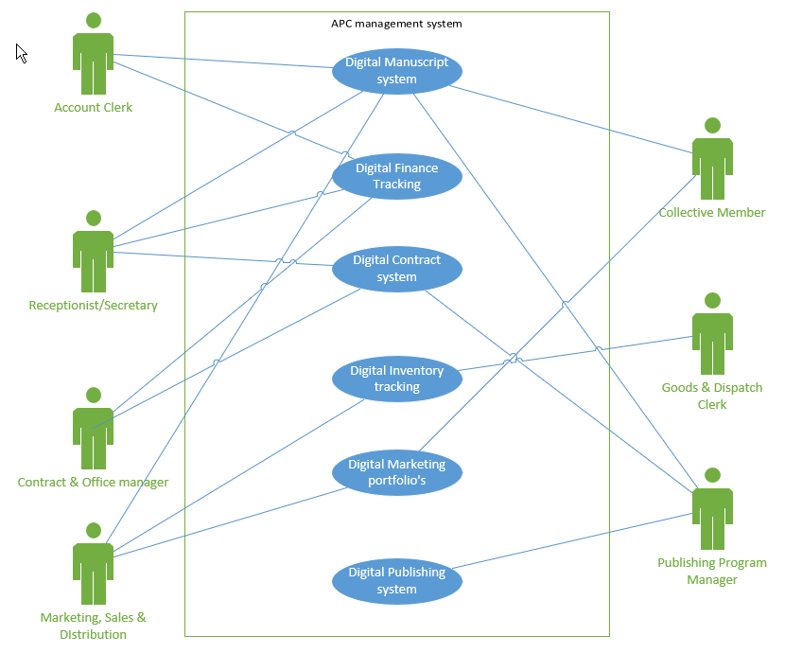

Figure : APC Use Case Diagram

**5.2 Data Flows**

A Data Flow Diagram is a system that is graphically represented. It can contain data flows, processes, sources, destinations, and stores. A Use Case Diagram shows you some of the use cases in your system, some of the actors in your system, and the relationships between them. Since data flows show what the users will be putting into the system and taking out it’s a much more detailed representation of the

By creating both different levels of data flow diagrams you are able to convey major tasks that are expected of employees through the new system, and also how they will connect to the different processes.

The level 0 data flow diagram shows the employees right away what their main tasks will be and whether or not they are inputting information into the system or taking out information. Level 1 then will allow them to see where that data is going specific to their instance of work. Having this will allow APC’s team to learn their new system and its processes much faster and can clear up miscommunications that would arise if there were no visual representations.

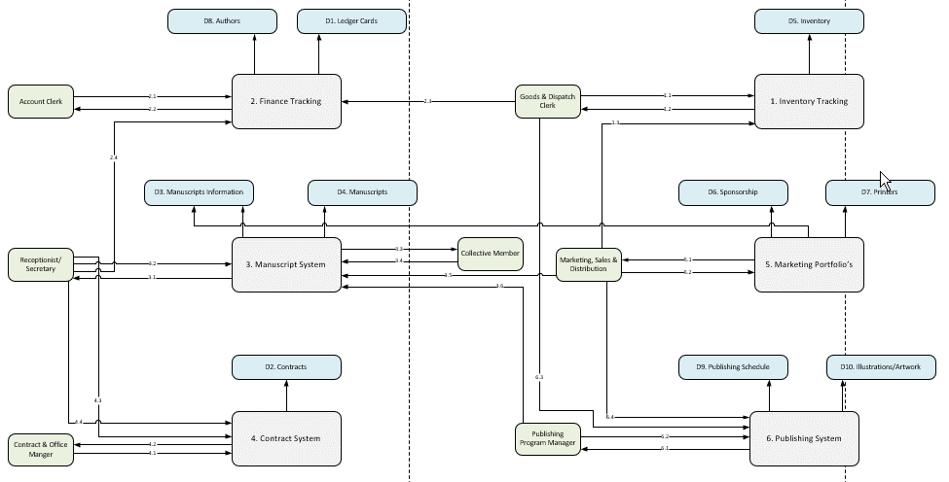

Figure : Data Flow Diagram

**5.3 Entity Relationships**

An entity relationship diagram allows you to show the relationships of entity sets stored in a database. An entity in this context is a data component that is used in the systems and processes that have been developed by the data flow diagram. Think of this diagram as the more refined data flow diagram that shows exactly what kind of data is passing through the systems.

Some important parts of the Entity diagram are the elements that are inside the entities. These are referred to as data types. This is important to note because this is what signifies what kind of data is going into the entity and then into a database. Noting these data types is also very important for the creation and editing of a systems database since databases all have set fields that require a single data type. See figure 3 below.

By defining the entities and attributes along with showing the relationships between them this diagram can illustrate the structure that is implemented in the database systems. This would be very important for figuring out data transmission from process to process and could be helpful for employees to know where data should be going.

**5.4 Structure Design**

The structure design of a system is in close connection to the human computer interface and deals with what is expected when a user performs and action in the systems interface. As shown in the human computer interface design of the physical applications and system interface is the main concern but with structure its more of the behind the scenes. All the information from the interface design is taken into account when creating the structure design. Looking at those design elements and then thinking what should happen when a user clicks a button is a huge part of the overall system design and is what goes into structure diagrams. This is another nonfunctional requirement for the project but key to a working user interface.

As far as the actual chart goes the components are referred to as modules which will represent different components in the system. Each module of the chart is shown in a level format from top to bottom. Level 1 being at the top and level 3 at the bottom. Then there are the subroutines of the system which live under each module. These are typically after level 2 and are organized left to right as in order of occurrence. In between levels 2 and 3 you will see arrows which represent data transfer between each module. The arrows direction represents the direction of the data, and the text will explain the purpose of the transfer.

You will see simple line connections that connect module to module and represent the connection to the overall system parts. There is also a rhombus shape that is used to represent a two-way decision such as true or false, or yes or no. This shape is located under a module where the decision would occur. See figure 5 below.

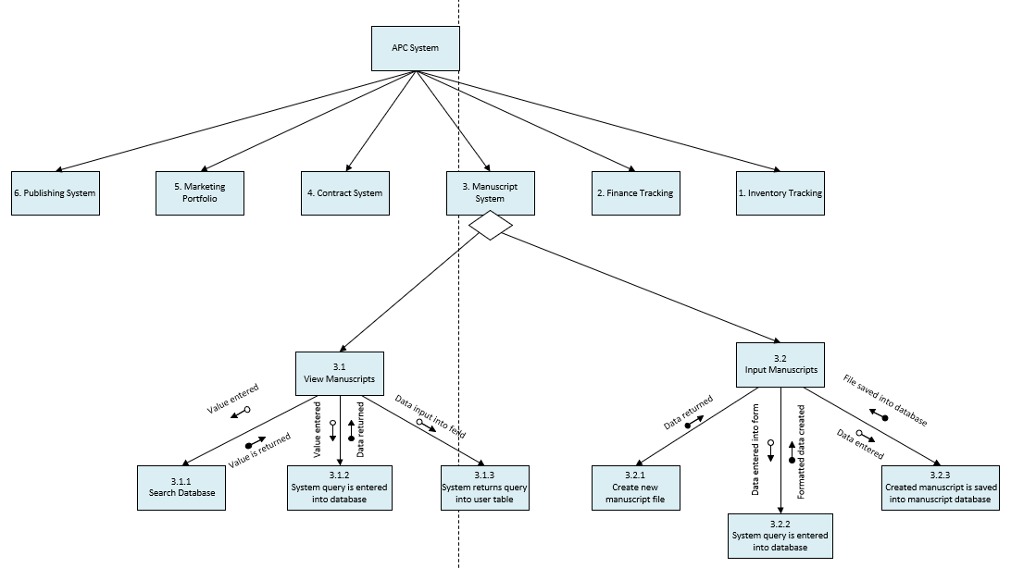

Figure 3: Structure Chart

**Inquiry Findings**

**6.1 Requirements for Project Design**

In order to implement all the systems and processes listed in the introduction and design element sections there are several requirements that will need to take place for this proposed project. These requirements are physical needs that will have to be implemented to support the systems that have been designed and would be implemented in this project. As a reminder the 6 systems are: Inventory tracking, Finance tracking, Manuscript system, Contract system, Marketing Portfolio, and Publishing System. All of these systems will require addition server and application support in order to work. The following information is the APC system requirements for those internal systems with current employee and system demands. If employee’s increase devices will be added but networking is already created to handle more employees.

*Physical Devices*:

8x Dell 27-inch monitors

8x Windows 10 installations

1x xerox versalink c505/s printer

*Applications*:

kintone database software/system

*Networking*:

1x Synology RT2600ac router

1x 200 Mb/s synchronous ISP service

1x 24-port NETGEAR GS324TP – Switch

2x Cat5e solid PVC cable 1000ft

20x Cat5e punch down keystone jack

1x hosted azure data storage servers (1tb upgradable)

**Project Challenges**

This was a relatively large project with many different elements that had to be constructed from the ground up. This meant that many challenges were created by having to identify all the different requirements for this project. As stated previously all information from APC was achieved through general complaints and interviews from the APC employees. This means that no actual requirements were presented from APC when in contact with me for system design. So, I had to define the requirements for the APC project proposal so that they could achieved their broad goals that were discussed in the introduction.

The next challenge that was faced when creating this proposal was the lack of testing. System functionality is a huge part of this project working and since there is no information pertaining to the users of this system beside there day to day tasks some problems could arise. For example, a possible problem could be that the APC employees are not accustomed to this level of technology that could be implemented in this proposal. This is mostly to do with the UI of the systems applications but also the overall change of workflow and general technology experience.

If I were to redo this project with a different outlook, I would have made a pre-project proposal with all requirements that I created in it. Then this could be reviewed and approved by the APC team so that I could then continue creating the more in-depth project. This would eliminate possible problems that could arise as described above.

**Conclusion**

Thank you for taking the time to review this project design proposal for the new APC system upgrade. APC's venture into a new business area comes with a great need to explore the technical environment, which opens up a wide range of possibilities to explore. All the above topics and system requirements were chosen based on the needs and potential wants for APC in the future. I hope my proposal outlined a successful plan of action for APC and also meet all expectations for your new business venture.

Certain aspects of this project can be flexible and changed based on different needs of APC. If these such needs arise or changes needed to be made simple communication of those needs to me is all that is needed to update this design proposal.

**Appendix A**

The Process of APC workflow with new business model

In order to streamline their new business processes, APC needs to shift from a paper-based system to digital in order to keep accurate and better track of their projects. This will help with efficiency, but also information loss which they detailed as a huge problem in their current system. Since all projects will be digital, they can be further organized and categorized by genre and trend to make decisions for the collective easier.

This technical description will be a great overall outline for the APC team to review and look through when training to use their new system that is being developed. Then when future explanation is needed more in-depth documents can be reviewed. The APC workflow description is as follows:

1. Email is sent to APC's specific email account for manuscripts with manuscript attached to it and authors personal information.
2. That manuscript attachment is then put into the manuscript system which will have a folder entitled with the manuscript title and the authors credentials by (Receptionist/Secretary).
3. An alert is then sent to (Marketing, Sales & Distribution), (Account Clerk), and (Publishing Program Manager) that a new manuscript has arrived.
4. A new publishing schedule is started for the (Publishing Program Manager) in the publishing system with the manuscript information imbedded.
5. Then (Account Clerk) will create a ledger card in the Finance system which will be tagged to the manuscript folder for future account information.
6. Then the manuscript is sent to (Collective Members) for first review. This is tracked on publishing system.
7. After interest in the manuscript is confirmed (Marketing, Sales & Distribution) will review manuscript, put marketing information plan in folder with manuscript. This is tracked on publishing system.
8. Then (Receptionist/Secretary) gets notice of confirmed interest and emails author about. This is tracked on publishing system.
9. (Collective Members) come back with reviewed copy of manuscript which is put in folder marked as reviewed/changed. This is tracked on publishing system.
10. (Contract & Office Manager) finds appropriate contract and fills out and changes details to reflect publishing offer. This is tracked on publishing system.
11. (Receptionist/Secretary) sends new revised copy of manuscript and contract offer to author pending approval. This is tracked on publishing system.
12. If author agrees then (Receptionist/Secretary) updates publishing schedule with a "confirmed interest selection". An alert is then sent to (Marketing, Sales & Distribution), (Publishing Program Manager), and (Contract & Office Manager). This is tracked on publishing system.

12a. If the author does not agree then issue is discussed by (Contract & Office Manager) or (Receptionist/Secretary) and resolved pending management approval. and then follows steps above ^ This is tracked on publishing system.

1. After this (Publishing Program Manager) will need to construct publication cost estimate breakdown and create art materials and illustrations if needed. This is tracked on publishing system.
2. Then (Marketing, Sales & Distribution) creates/files ISBN for the manuscript and stores information in manuscript folder, along with check the box on publishing schedule for such a task. An alert is sent to (Marketing, Sales & Distribution) for reviewing purposes. This is tracked on publishing system.
3. Then (Marketing, Sales & Distribution) will create a information packet based on (Publishing Program Manager) breakdown. The packet will contain the printers and distribution businesses that will be used. This is tracked on publishing system.
4. Then the entire manuscript packet that was prepared by (Marketing, Sales & Distribution) will be sent to the (Collective Members) pending their approval. This is tracked on publishing system.
5. If approved then an alert is then sent to (Publishing Program Manager), (Contract & Office Manager), (Marketing, Sales & Distribution), and (Receptionist/Secretary) who will alert the author that APC is going to be publishing their book. This is tracked on publishing system.
6. Then depending on contract details possible author compensation will be a possibility which means (Account Clerk) will be notified that manuscript publishing is happening and to contact (Contract & Office Manager) for details. This is tracked on publishing system.
7. After this (Publishing Program Manager) will finalize book construction and printing details with (Marketing, Sales & Distribution) and prepare to print copies. This is tracked on publishing system.
8. (Account Clerk) will be notified of incoming expense for printing of new published manuscript, and (Goods & Dispatch Clerk) will be alerted and to expect pre-print copies to arrive for review. This is tracked on publishing system.
9. When pre-print copies arrive (Goods & Dispatch Clerk) notes them in Inventory tracking system and then distributes to (Marketing, Sales & Distribution), (Publishing Program Manager) for review pending approval. This is tracked on publishing system.
10. If approved, then (Publishing Program Manager) contacts printing company to complete their set buy order that was outlined in the publishing outline earlier. This is tracked on publishing system.
11. When official printed copies arrive (Goods & Dispatch Clerk) notes them in Inventory tracking system, which alerts (Marketing, Sales & Distribution). This is tracked on publishing system.
12. (Marketing, Sales & Distribution) then contacts buyers of official copies and notifies (Goods & Dispatch Clerk) where to send through request to Inventory tracking system. These requests are also sent to (Account Clerk) who notes the buy order in Finance Tracking system.
13. Publishing system timeline for this manuscript is closed. Alert sent to (Publishing Program Manager)

The new workflow process that APC will utilize is entirely digital system that will allow for multi system integration. This means that there will be separate systems that are in-charge of certain smaller business processes in a digital format.

Pending testing and changes the new APC workflow system will completely change the way that they go about their day-to-day work. All files will be digital, and be exchanged, edited, and tracked digitally. This will eliminate previous problems that APC had in the pass, along with optimizing their performance for future business endeavors like electronic media.

**Appendix B**

New manuscript workflow process (Receptionist/Secretary)

This detailed instruction document is used for the Receptionist/Secretary position at APC and will detail exactly how that employee will go about starting the new manuscript process. This process will most often start when a new manuscript is sent to the dedicated email for APC and then will be transferred to the correct location by the Receptionist/Secretary. All information in this document will show exactly where and how this process should be done and any information that is unknown is located in previous documents such as the technical description of APC's workflow process.

Step-by-step Instructions

1. Incoming email is sent to APC's specific email account for manuscripts with manuscript attached to it and authors personal information.
2. As the main person to have access to said email account (Receptionist/Secretary) will get a notification from there office computer that a new email has arrived.
3. After seeing this notification, the email will be opened and read over in its entirety by (Receptionist/Secretary).



1. While reading over this new email (Receptionist/Secretary) needs to check for several key elements.
   1. author full name
   2. authors contact information.
   3. attached manuscript.
   4. any other author demands and or details that are important to publishing.
2. After reading over this information (Receptionist/Secretary) will forward said email to (Account Clerk) who will create a new ledger card.
   1. creation of new ledger card with "new manuscript" box checked will also create new manuscript folder in manuscript system with relevant information already filled in.
3. While ledger card is being created (Receptionist/Secretary) create temporary folder on their desktop computer.

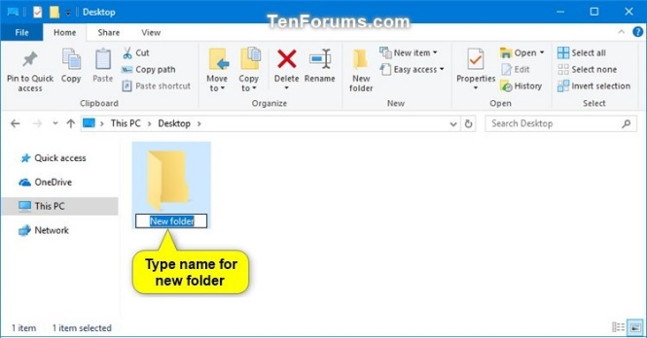

1. Then (Receptionist/Secretary) will move all information from the email detailed above into the temporary desktop folder.
   1. this folder will follow the name convention of author last name then first name then title of manuscript.
2. Then (Account Clerk) notifies (Receptionist/Secretary) that ledger card is created.
3. (Receptionist/Secretary) will move that temporary folder into the manuscript database through the manuscript system.
   1. This is done by first accessing manuscript system through desktop application, and logging in.

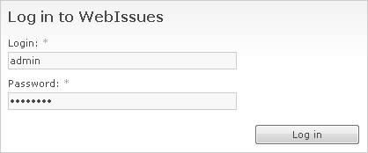

* 1. Finding new manuscript for specific author and manuscript by using search bar in manuscript system.

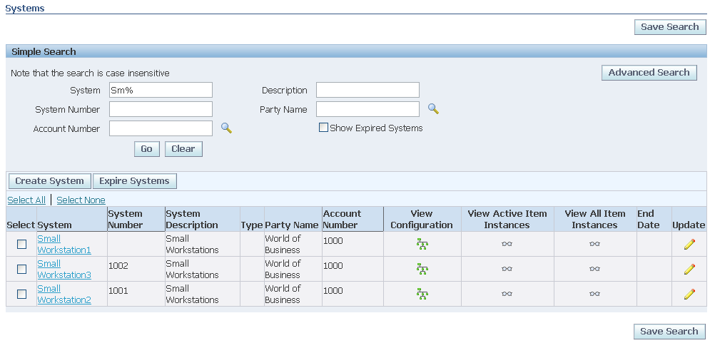

* 1. Then moving folder using simple drag and drop feature where you would drag the temporary desktop folder into the correct manuscript folder in the manuscript system.

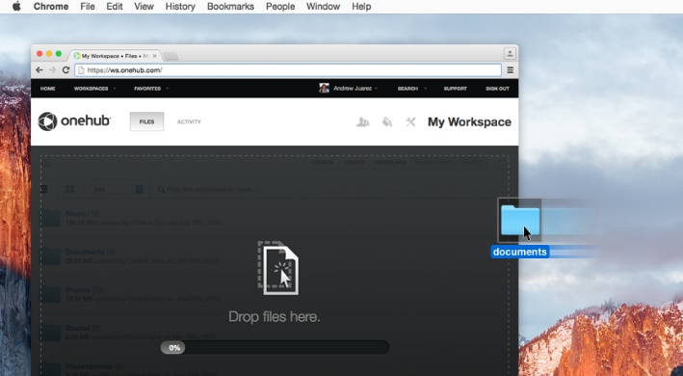

1. (Receptionist/Secretary) then goes to publishing schedule program to confirm new manuscript information has been moved.
   1. This is done by first accessing publishing schedule program on desktop, and logging in.
   2. Then finding specific author and manuscript by using search bar in publishing schedule program.
   3. After accessing said schedule (Receptionist/Secretary) will check that a new manuscript folder has been created.

Closing statements

This process will explain how the Receptionist/Secretary should carry out this task and if done properly will fulfil the needs in the new APC workflow process. If problems arise with system connections when doing said process or loss of information there can be a serious workflow problem and will have to be dealt with accordingly by the IT department.

In summary this document details exactly how a Receptionist/Secretary at APC will complete the creation, filing, and check of new and incoming manuscripts. All technical training for using the new APC system such as the manuscript system are not detailed in this document and will be dealt with separately. If Receptionist/Secretary needs this knowledge before reading this document, please review the new systems document that will explain exactly what and how to use the new systems. This document would be entitled "New APC systems" and then the subtitles of each individual system that you might need to review.